Name: ______________________________________ | Date: ___________________

Creating a Scale Model

Consider the device you are wanting to create. Is it a larger design? If so, you may need to create a scale model instead of making the design actual size. Sometimes for a presentation, a designer will create a prototype, or a physical model, of the device they are wanting to mass manufacture. Some smaller prototypes allow investors to envision how the product might function in real life, but other prototypes would be too big or expensive to create for the investors to view. Due to size or price constraints for creating a prototype, some designers create prototypes to scale.

To create a prototype to scale means that the prototype is made into a smaller version of the original device design and includes all parts of the design. If you have a larger device and need to scale down the design, follow the steps below to determine how to create the prototype.

Step 1
Draw out your current design below in Section A and include the measurements of your device. Do not worry about explaining the design features on this model, just focus on the size of the components. Make sure to include how wide and tall the design would be in real life (the dimensions of your device). Give your best approximations.

Section A  Current design with dimensions | Section B  Scale model design with dimensions

We want a model to be easily passed around and manipulated by the investors. A scale model of 6-12 inches works well for this purpose. When we scale down the model, we want it to be between 6 and 12 inches on its longest part.

When scaling down, we need to look at factors for each dimension of our device. We can use the Factors and Multiples Chart to help us determine the size that best fits our scale model. On this chart, the sizes we want our device to scale down to, or factors, are on the far left. The multiples of those numbers are to the right of that.

Factors and Multiples Chart
 | x2 | x3 | x4 | x5 | x6 | x7 | x8 | x9 | x10 | x11 | x12 | x13 | x14 | x15 | x16 | x17 | x18
6 | 12 | 18 | 24 | 30 | 36 | 42 | 48 | 54 | 60 | 66 | 72 | 78 | 84 | 90 | 96 | 102 | 108
7 | 14 | 21 | 28 | 35 | 42 | 49 | 56 | 63 | 70 | 77 | 84 | 91 | 98 | 105 | 112 | 119 | 126
8 | 16 | 24 | 32 | 40 | 48 | 56 | 64 | 72 | 80 | 88 | 96 | 104 | 112 | 120 | 128 | 136 | 144
9 | 18 | 27 | 36 | 45 | 54 | 63 | 72 | 81 | 90 | 99 | 108 | 117 | 126 | 135 | 144 | 153 | 162
10 | 20 | 30 | 40 | 50 | 60 | 70 | 80 | 90 | 100 | 110 | 120 | 130 | 140 | 150 | 160 | 170 | 180
11 | 22 | 33 | 44 | 55 | 66 | 77 | 88 | 99 | 110 | 121 | 132 | 143 | 154 | 165 | 176 | 187 | 198
12 | 24 | 36 | 48 | 60 | 72 | 84 | 96 | 108 | 120 | 132 | 144 | 156 | 168 | 180 | 192 | 204 | 216

For example, if your device is 48 inches tall, there are several options for scaling down the device. Both 6 and 8 are factors of 48. This means that the device can easily be scaled down in size to a 6-inch or 8-inch scale model. The same thing goes for devices that are 48 feet tall. Something 48 feet tall can easily be scaled down into something that is either 6 or 8 inches tall by using the scale factors.

Factors and Multiples Chart
 | x2 | x3 | x4 | x5 | x6 | x7 | x8 | x9 | x10 | x11 | x12 | x13 | x14 | x15 | x16 | x17 | x18
6 | 12 | 18 | 24 | 30 | 36 | 42 | 48 | 54 | 60 | 66 | 72 | 78 | 84 | 90 | 96 | 102 | 108
7 | 14 | 21 | 28 | 35 | 42 | 49 | 56 | 63 | 70 | 77 | 84 | 91 | 98 | 105 | 112 | 119 | 126
8 | 16 | 24 | 32 | 40 | 48 | 56 | 64 | 72 | 80 | 88 | 96 | 104 | 112 | 120 | 128 | 136 | 144
9 | 18 | 27 | 36 | 45 | 54 | 63 | 72 | 81 | 90 | 99 | 108 | 117 | 126 | 135 | 144 | 153 | 162
10 | 20 | 30 | 40 | 50 | 60 | 70 | 80 | 90 | 100 | 110 | 120 | 130 | 140 | 150 | 160 | 170 | 180
11 | 22 | 33 | 44 | 55 | 66 | 77 | 88 | 99 | 110 | 121 | 132 | 143 | 154 | 165 | 176 | 187 | 198
12 | 24 | 36 | 48 | 60 | 72 | 84 | 96 | 108 | 120 | 132 | 144 | 156 | 168 | 180 | 192 | 204 | 216

Step 2
Look at the Factors and Multiples Chart and see if the largest size you have identified on your drawing in Section A is on this table. If that size falls between 2 numbers in the table, round up or down to the nearest factor. Remember, you drew your model with your best approximation of the real size of your device. If you are having trouble picking out a scale factor, ask your teacher for help.

Step 3
Now that you have picked your scale factor, look back at your design drawing in Section A. Use Section B to redraw your device, but this time take each dimension in Section A and divide it by the scale factor you have identified for your scale model.

Following is an example for a pier, or post, that supports a bridge. The posts are being hit by boats, and the design is a padded barrier to help reduce the force of boats hitting the pier.
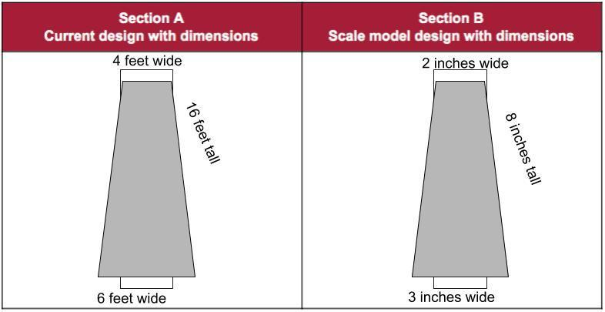

Step 4
Once you have your scale model drafted out, check with your teacher to be cleared for making an actual prototype.

